***Last digit of a number:***

num = input("Enter number: ")

no=(num[10:0:-9])

#print(no)

print("The last digit is: ")

if int(no)==0:

print("zero")

elif int(int(no))==1:

print("one")

elif int(no)==2:

print("two")

elif int(no)==3:

print("three")

elif int(no)==4:

print("four")

elif int(no)==5:

print("five")

elif int(no)==6:

print("six")

elif int(no)==7:

print("seven")

elif int(no)==8:

print("eight")

elif int(no)==9:

print("nine")

Output:

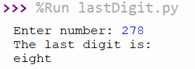

***Reverse of name:***

name=input('Enter name: ')

print(name[::-1])

Output:

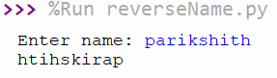

***Electricity bill:***

previous = int(input('previous reading: '))

current = int(input('current reading: '))

units = current - previous

amount = 0

if(units <= 50):

amount = 50

elif(units>50 and units<=100):

amount = units*2.5

elif(units>100 and units<=200):

amount = units*3.6

elif(units>200 and units<=300):

amount = units*4.4

elif(units>300):

amount = units*6

else:

print("Units cannot be negative")

amount = "N/A"

print("Bill amount is",amount)

Output:

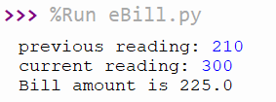

***Print name 50 times:***

name='parikshith \n'

print(name*50)

Output:

